

Name: Ali Bishar

Admission Number: BBIT/2024/60394

Unit Code: BIT3208

Unit Name: Advanced Web Design and Development

Semester: 3.2

Project Title: Alnoor Store – Smart E-Commerce Web Application

Technologies Used: PHP, MySQL, JavaScript, HTML5, CSS3, XAMPP

GitHub Repository: https://github.com/alibishar095-collab/alnoor-store

Contents
Table of Contents Error! Bookmark not defined.
Title: Installation and Testing of Local Development Environment 2
Week 2: Wireframes and GUI Design 7
Title: User Interface Planning and System Design 7
Week 3: JavaScript Basics & PHP Foundations 11
Title: Frontend Interaction and Backend Foundations 11
Week 4: Server-Side Components & Backend Development 16
Title: Dynamic Backend Processing and Authentication System 16
Week 5: Database Components & CRUD Operations 21
Title: Data-Driven Product Management System 21

Title: Installation and Testing of Local Development Environment

This week focused on setting up a professional local web development environment using XAMPP, testing the Apache and MySQL services, and establishing a successful database connection for the Alnoor Store project.

Evidence

Fig 1: XAMPP Control Panel showing Apache and MySQL services running
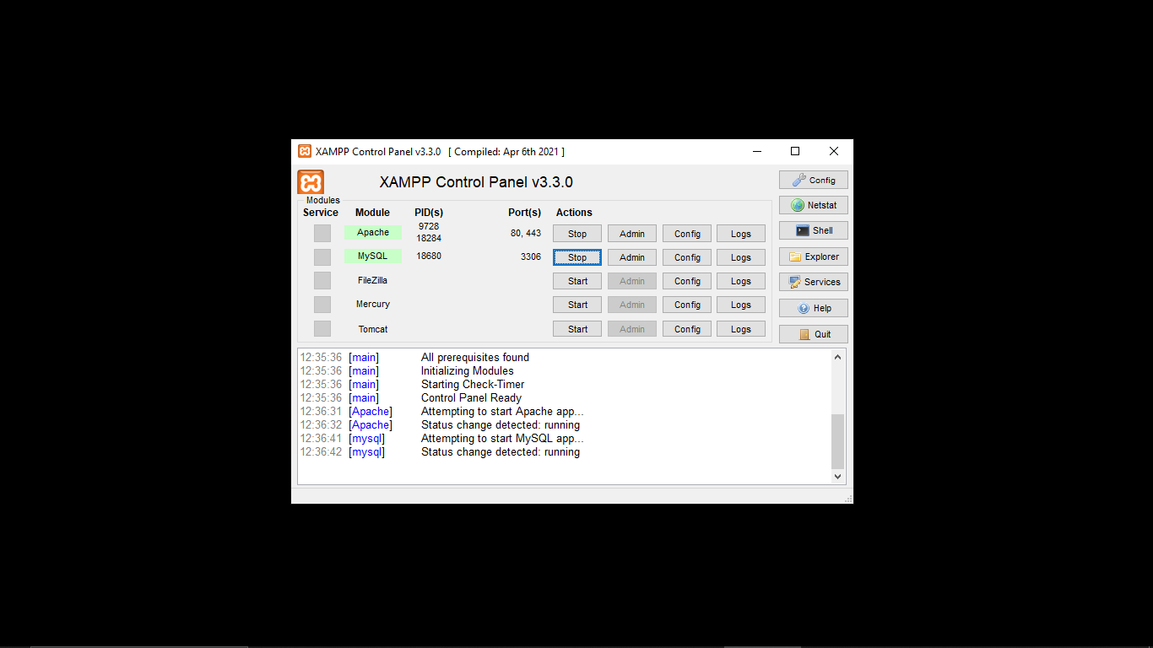

Fig 2: phpMyAdmin showing alnoor-store database created
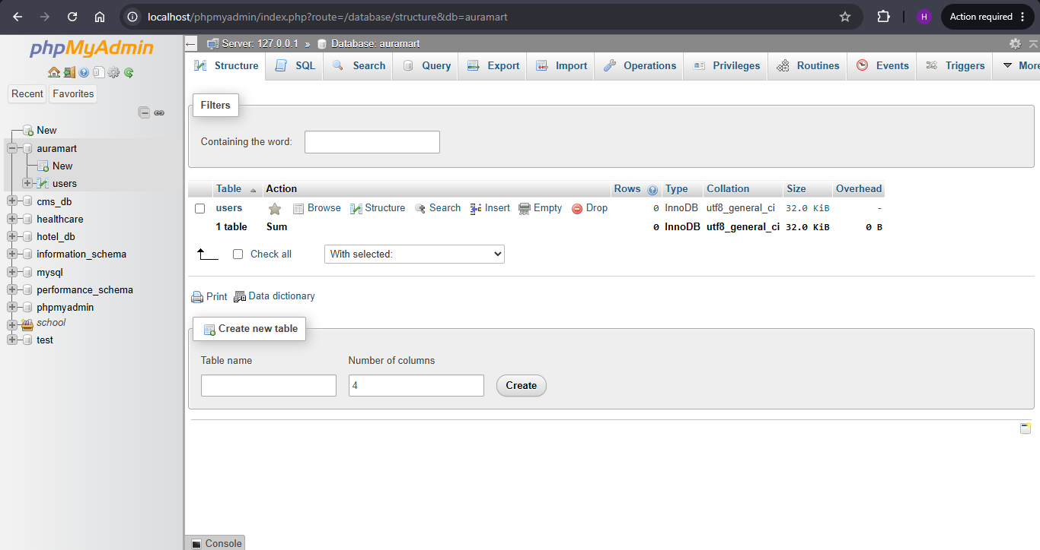

Fig 3: Localhost test page – index.html
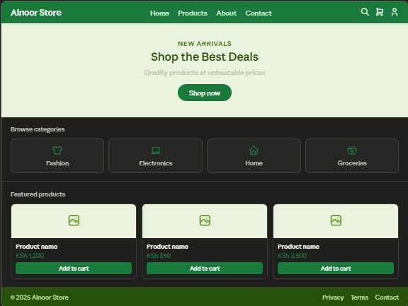

Fig 4: Hello World PHP test page
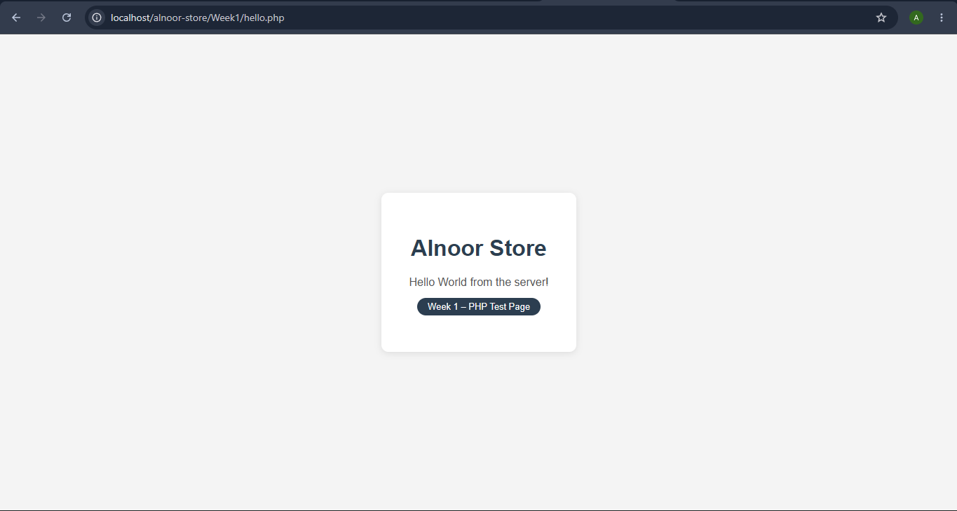

Fig 5: Database connection success
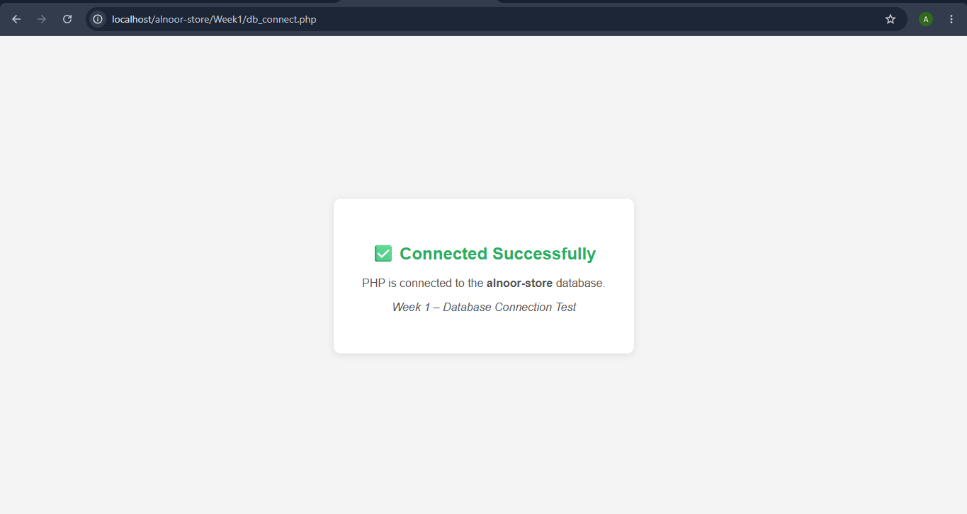

Reflection
Successfully installed and configured XAMPP, enabling both Apache and MySQL services to run simultaneously on localhost. I created the alnoor-store database using phpMyAdmin and confirmed a successful PHP-MySQL connection. The Hello World PHP page confirmed that the server correctly processes server-side scripts. A key challenge was understanding the relationship between Apache serving files and PHP executing on the server. The database connection test in Fig 5 was particularly important as it validated that the entire stack i.e Apache, PHP, and MySQL was correctly configured.

Week 2: Wireframes and GUI Design

Title: User Interface Planning and System Design

This week focused on planning the Alnoor Store user interface before writing any functional code. Wireframes and GUI mock-ups were designed to establish the visual identity, navigation flow, and user experience of the e-commerce platform. A minimal and modern layout style was selected with a Green and White colour theme reflecting the brand identity.

Design Decisions

Color Theme | Green (#1a7a3c) and White — clean, professional, Islamic aesthetic
Layout Style | Minimal & Modern — whitespace-focused, clean typography, subtle green accents
Store Type | General Merchandise — Fashion, Electronics, Home & Living, Groceries
Target Users | Admin (store management) and Customer (shopping)
Typography | Segoe UI — clean, modern, highly readable across devices

Evidence

Fig 1: Registration wireframe

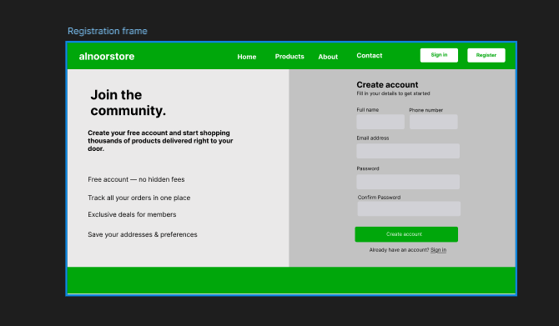

Fig 2: Login page wireframe using a split-panel layout — branding and features on the left, sign-in form on the right.
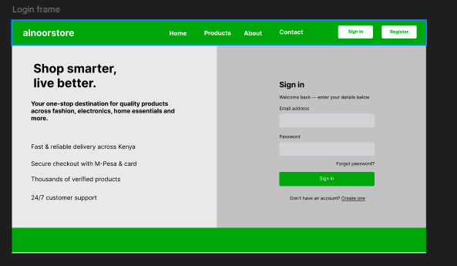

Fig 3: Admin dashboard wireframe showing the sidebar navigation, overview stat cards, and recent orders and products tables.
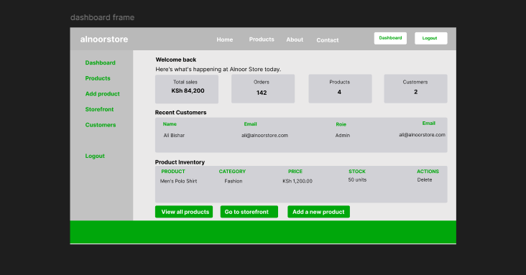

Fig 4: Color theme showing the primary green (#1a7a3c), dark green (#27500A), light green (#eaf3de) and white palette used across Alnoor Store.



Fig 5: Product catalogue wireframe showing the search bar, category filter, and responsive product card grid layout.
.

Reflection
The wireframes were designed with user experience as the primary consideration. The split-panel layout for login and registration separates branding from functional elements. The dashboard was designed with a persistent sidebar to ensure administrators can navigate efficiently without losing context. The green and white colour theme was deliberately chosen to create a clean, trustworthy feel appropriate for an e-commerce platform serving a Kenyan market. Navigation was planned to require minimal clicks to reach any key section of the store.

Week 3: JavaScript Basics & PHP Foundations

Title: Frontend Interaction and Backend Foundations

This week introduced JavaScript for client-side interactivity and PHP for server-side processing. Key deliverables included form validation, DOM manipulation, PHP syntax practice, and a database connection test.

Files Created

login.html | Login form with JavaScript validation and password strength checker
register.html | Registration form with JS validation including password match check
validation.js | Shared JavaScript file handling all form validation logic
dom.html | 6 DOM manipulation demos: live preview, category menu, toggle, counter, color changer, character count
hello.php | PHP syntax practice — variables, echo, loops, server time
form_process.php | PHP form processor — sanitizes input, validates, displays result
db_connect.php | PHP-MySQL database connection test using mysqli_connect()
alnoor-store.sql | Week 3 database export with users and products tables

Evidence
Fig 1: Login form validation using JavaScript preventing submission of empty fields and invalid email format, with red error messages displayed below each field.
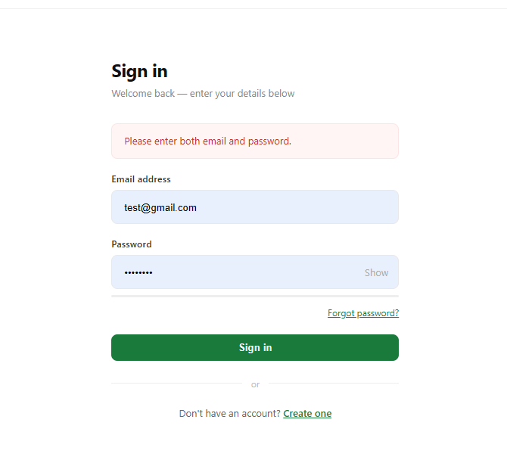

Fig 2: Password strength checker on the registration form dynamically updating a colour-coded bar and label (Very Weak to Very Strong) as the user types.
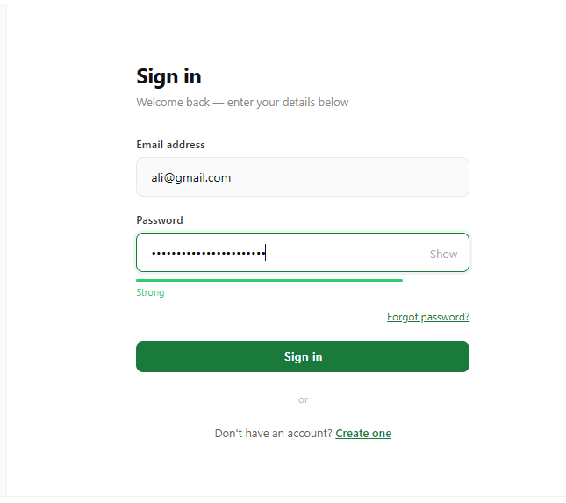

Fig 3: DOM manipulation demonstration page showing six interactive demos including live text preview, dynamic category menu, show/hide toggle, cart counter, colour changer, and character counter.

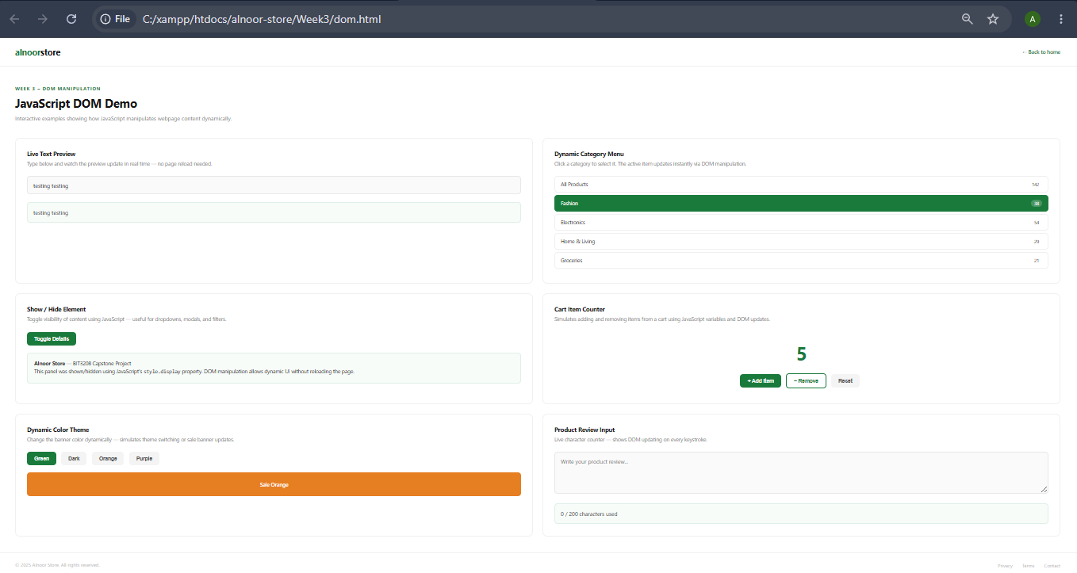

Fig 5: db_connect.php confirming successful PHP-MySQL connection to the alnoor-store database, displaying the MySQL server version and connection timestamp.


Reflection
JavaScript form validation this week prevented invalid data from being submitted to the server, improving user experience significantly. The password strength checker demonstrated real-time DOM manipulation responding to each keystroke. PHP was introduced as the server-side counterpart while JavaScript runs in the browser, PHP executes on the server before sending the response. The form_process.php file showed how PHP sanitizes and validates data server-side as a second layer of security. The database connection confirmed that the backend stack is fully functional and ready for CRUD operations in the coming weeks.

Week 4: Server-Side Components & Backend Development

Title: Dynamic Backend Processing and Authentication System

This week transformed the static prototype into a fully dynamic, session-based web application. Users can now register, log in securely, access a protected dashboard, and log out. All pages share a centralized database connection and stylesheet, establishing a professional project architecture.

Folder Structure

includes/db.php | Shared database connection used by all PHP files via require_once
includes/header.php | Shared HTML header — dynamic logo, nav, session-aware buttons
css/style.css | Global stylesheet shared across all pages — buttons, forms, tables, layout
register.php | Registration form — validates input, hashes password, inserts into users table
login.php | Login form — verifies credentials using password_verify(), sets session
dashboard.php | Session-protected dashboard — displays live users and products from database
logout.php | Destroys session, shows goodbye message, auto-redirects after 5 seconds
index.php | Dynamic homepage — hero section, category pills, product cards from database

Key Technical Concepts

- Prepared statements using mysqli_prepare() prevent SQL injection attacks
- password_hash() stores passwords securely. Never stored as plain text
- password_verify() checks submitted password against the stored hash
- session_start() and $_SESSION variables maintain user state across pages
- Role-based content: admin sees Edit/Delete buttons, customers see Add to Cart
- __DIR__ used for reliable file paths across all require_once calls

Evidence

Fig 1: Registration form submitting successfully with the new user record visible in phpMyAdmin showing the bcrypt-hashed password stored in the users table
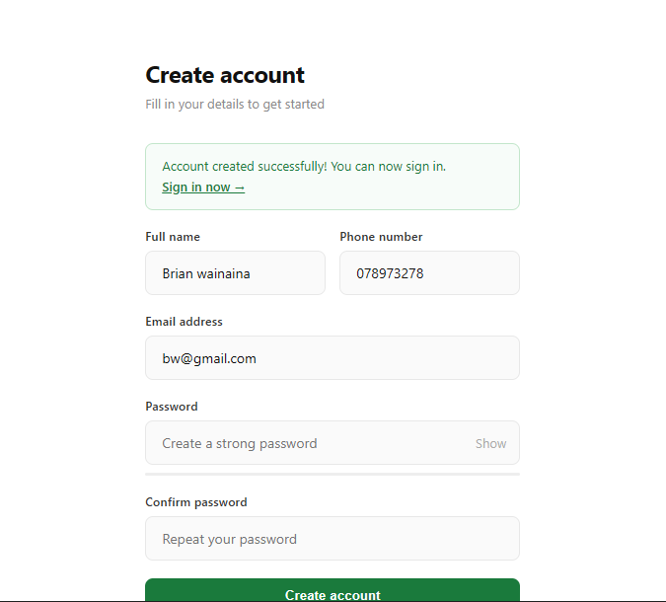

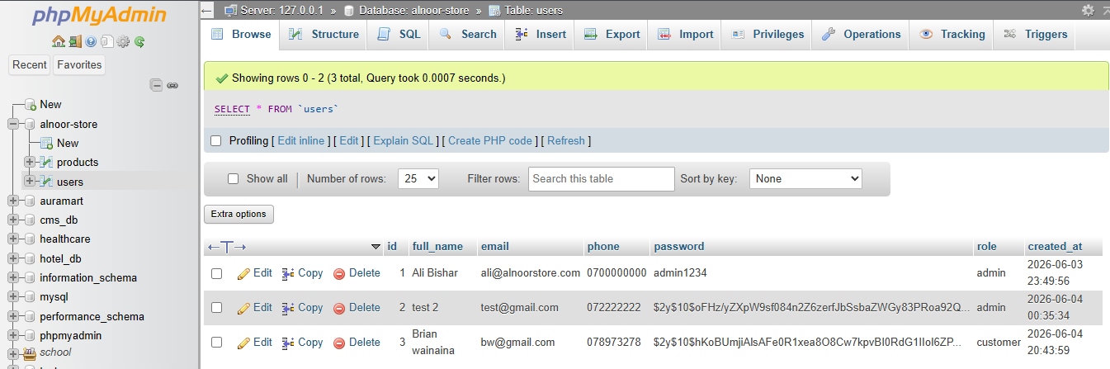

Fig 2: Login form authenticating user credentials against the database and redirecting to the session-protected dashboard upon successful verification
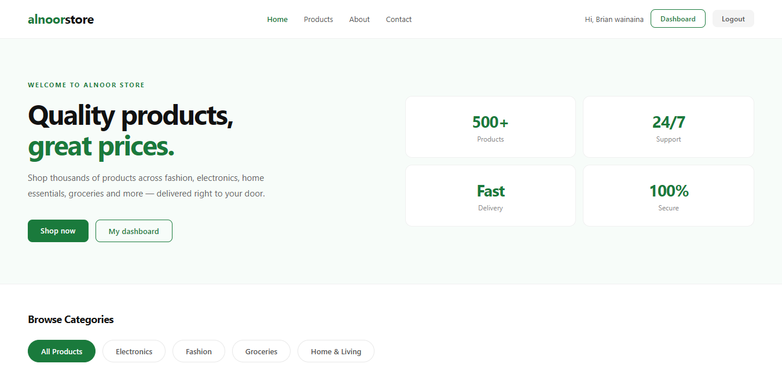
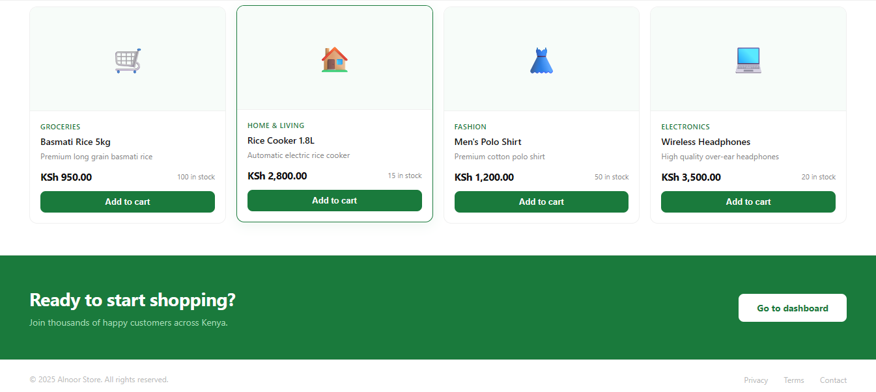

Fig 3: Admin dashboard showing the personalized welcome message, live stat cards, recent customers table and product inventory — all data pulled dynamically from the alnoor-store database.
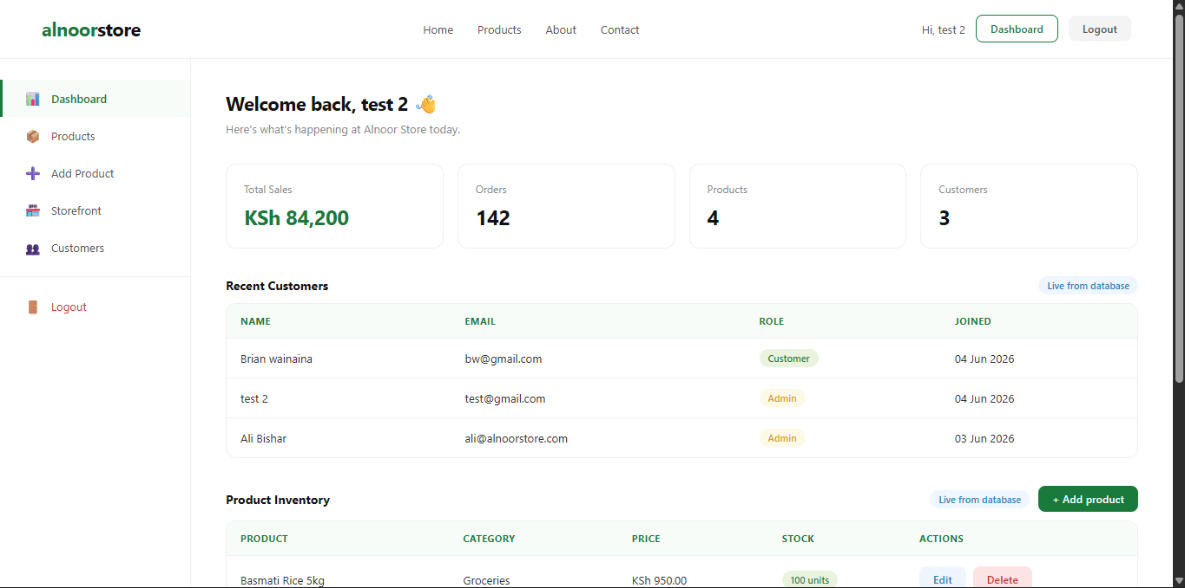
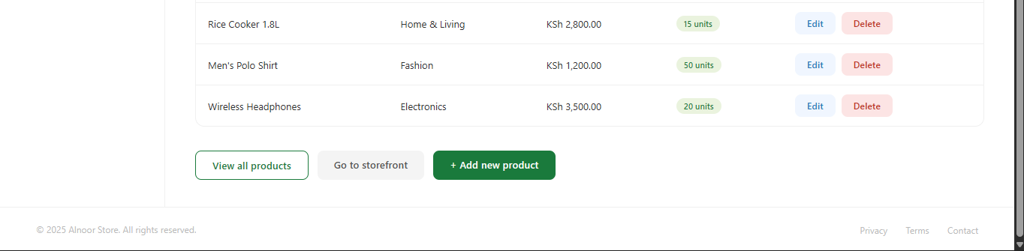

Fig 4: Logout page displaying the user's name in the goodbye message after session destruction, with a 5-second auto-redirect countdown to the homepage.
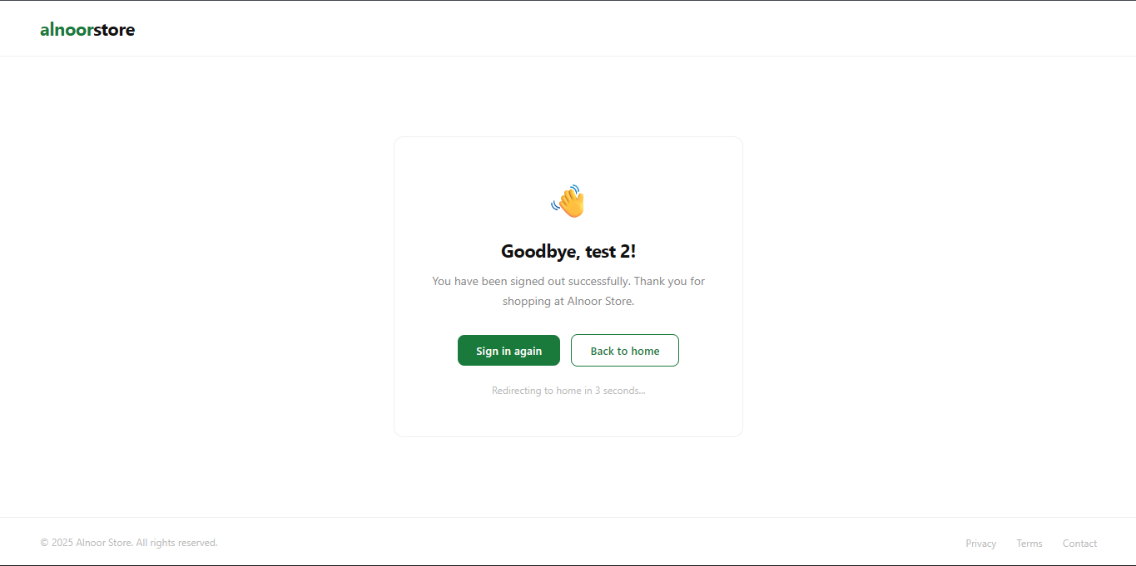

Fig 5: admin product tab
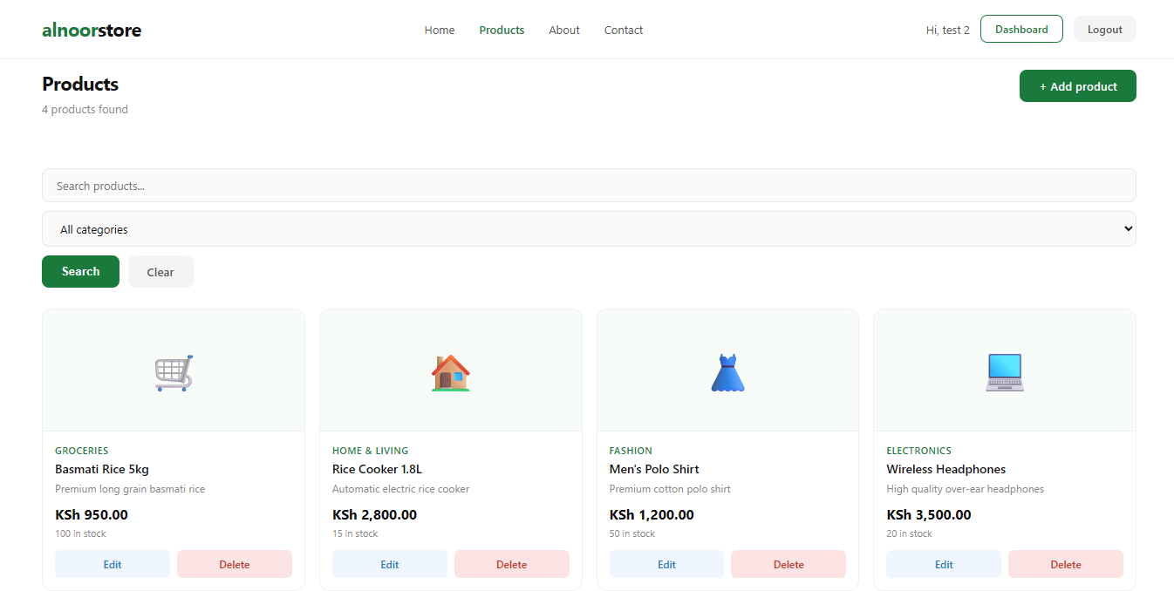

Reflection
The system moved from static pages to a fully dynamic, database-driven application. Using prepared statements for all database queries ensures the application is protected against SQL injection — a critical security requirement for any e-commerce system. Password hashing using PHP's password_hash() with bcrypt ensures that even if the database were compromised, user passwords would remain secure. The shared includes/db.php and css/style.css files demonstrate the DRY principle, making the codebase easier to maintain and scale as new pages are added.

Week 5: Database Components & CRUD Operations

Title: Data-Driven Product Management System

This week built the full product management system implementing all four CRUD operations Create, Read, Update, and Delete. The products module allows administrators to add, view, edit, and delete products from the alnoor-store database, while customers can browse and search the catalog.

CRUD Operations Implemented

CREATE (Add) | products/add.php — form to insert a new product into the database
READ (View) | products/index.php — displays all products with search and category filter
UPDATE (Edit) | products/edit.php — pre-filled form to update an existing product record
DELETE (Remove) | products/delete.php — confirms and removes a product from the database

Folder Structure

Week5/products/index.php | Product catalog — search, filter, display all products
Week5/products/add.php | Add new product form with validation
Week5/products/edit.php | Edit existing product — pre-filled form
Week5/products/delete.php | Delete product with confirmation
Week5/includes/db.php | Shared database connection
Week5/includes/header.php | Shared header with session-aware navigation
Week5/css/style.css | Global stylesheet
Week5/alnoor-store.sql | Updated database export with full schema

Evidence

Fig 1: Read operation - Product catalog page showing all products retrieved from the database in a responsive grid, with a working search bar and category filter dropdown.


Fig 2: Create operation - Add product form allowing administrators to insert a new product record into the database, with server-side validation and success confirmation.
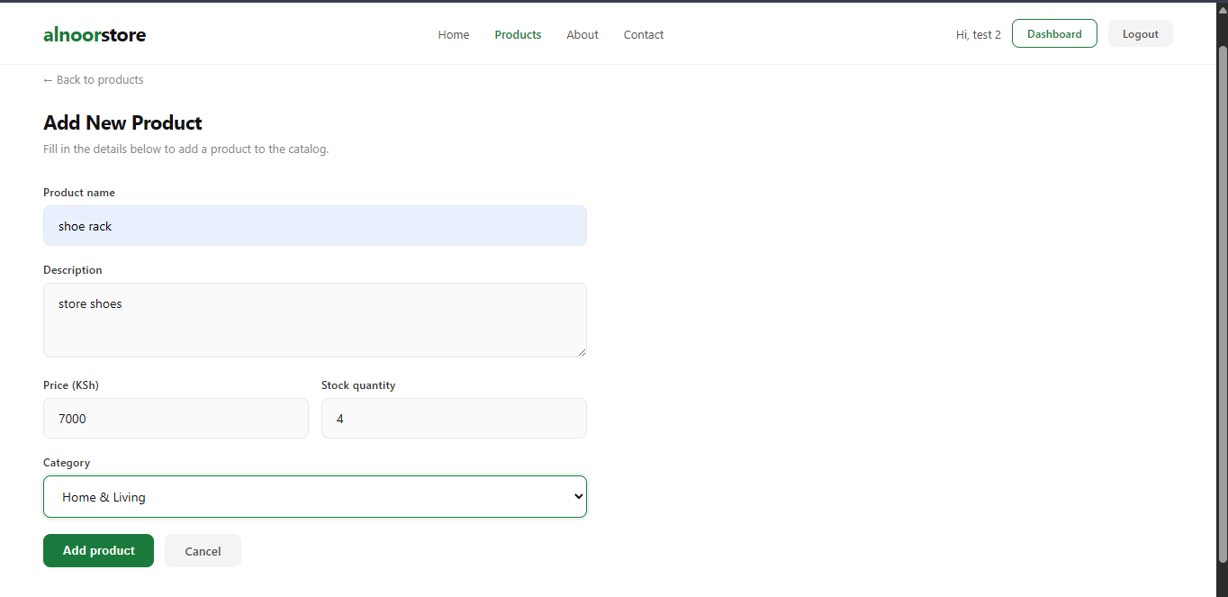

Fig 3: Update operation - Edit product page with form fields pre-populated from the database record, allowing the administrator to update product details and save changes.
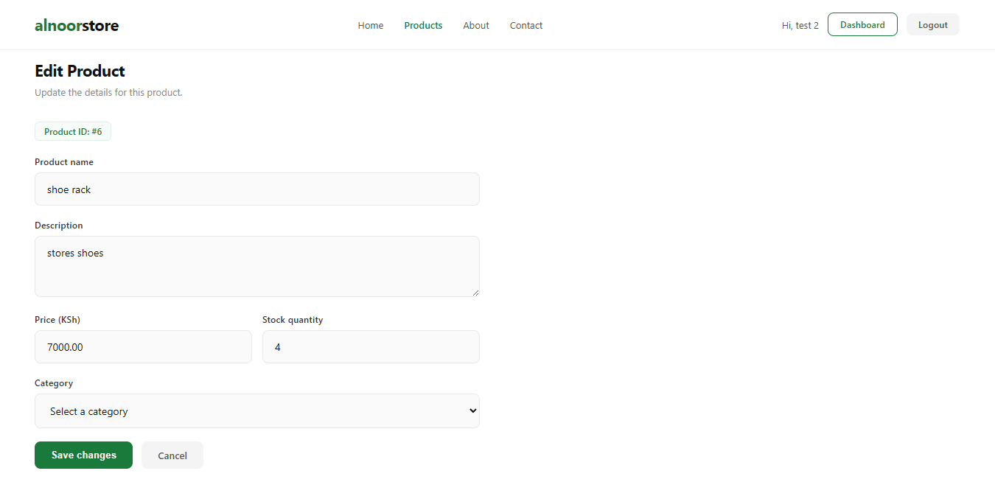

Fig 4: Delete operation - Delete operation removing a product record from the database after confirmation, with a success message and redirect back to the product catalog.

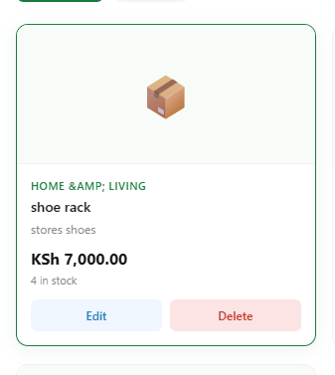

Fig 5: phpMyAdmin showing updated product records - phpMyAdmin products table confirming all CRUD operations reflected correctly in the database — new records added, existing records updated, and deleted records removed.

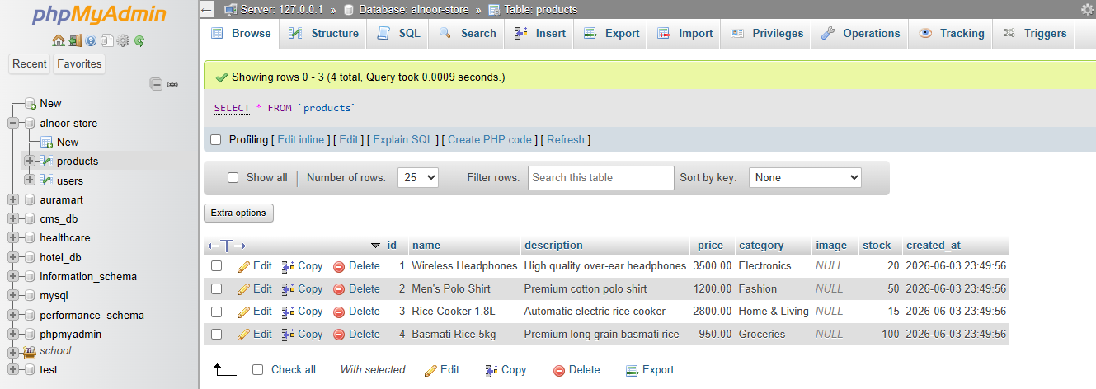

Reflection
Week 5 completed the core database interaction layer of Alnoor Store. Implementing all four CRUD operations demonstrated the full lifecycle of data in a web application. The search and filter functionality on the product catalog showed how SQL WHERE clauses can be built dynamically based on user input. Role-based access control ensured that only administrators see the Edit and Delete buttons, while customers only see the product catalog. Using mysqli_real_escape_string() for search queries and prepared statements for all write operations maintained the security standards established in Week 4. The products module forms the foundation for the shopping cart and order management system to be built in subsequent weeks.

